# Section: 14-3: Second to Fourth Vassa Spent in Rājagaha (Age 36-39)

In the previous section (14-2), we saw the Blessed One returning to Rājagaha from Kapilavatthu, pausing at the Anupiya Mango Grove in Malla country, where he gathered more disciples before continuing his journey. According to tradition and scriptural accounts, the Buddha spent his second to fourth vassa in and around Rājagaha, deepening the dissemination of the Dhamma and offering invaluable guidance to both monastics and lay followers.

## Significant Events During This Period

### Dhamma Advice Given to Novice Rāhula

During his second vassa at the Veluvana Monastery, the Blessed One offered profound teachings to Venerable Rāhula, who was residing in Ambalatthikā at the time. [1] Knowing that Rāhula had taken up the monastic path at a tender age, the Buddha imparted essential lessons that would serve as the foundation of his spiritual journey.

### Key Teachings

#### The Peril of Falsehood

Using the simile of a pot, the Buddha emphasized the dire consequences of speaking falsehood: [2]

* Just as a pot containing only a little water is nearly empty, even so, one who is unashamed to utter a deliberate lie has diminished their spiritual life.
* Just as water poured out of a pot is lost, even so, one who tells deliberate lies has discarded the path of a recluse.
* Just as an upturned pot can hold nothing, even so, one who tells deliberate lies has overturned their commitment to the holy life.
* Just as an empty pot stands hollow and void, even so, is the recluse-ship of one who speaks falsehood without shame.

Thus, the Blessed One urged: *“****Therefore, Rāhula, you should train yourself thus: ‘I will not utter a falsehood even as a joke.’[3]***

#### Mindfulness in Bodily, Verbal, and Mental Actions

The Buddha further guided Venerable Rāhula on the necessity of wise reflection before engaging in any action. Using the simile of a mirror, he illustrated that just as one examines one’s reflection in a mirror, so too should one examine one’s thoughts, words, and deeds with careful introspection.

The Buddha advised:

*“Rāhula, when you wish to perform an action by body, speech, or mind, you should reflect: ‘Would this action lead to my own affliction, to the affliction of others, or to the affliction of both? Is it an unwholesome action with painful consequences and results?’ If, upon reflection, you discern that such an action would lead to harm, you should refrain from it.”[4]*

**Furthermore**, the Blessed One expounded that one should reflect **before**, **during**, and **after** an action to assess its wholesomeness. If, upon honest reflection, one recognizes an action as unwholesome, immediate correction should follow. Even if the deed is already done, the practitioner should feel sincere remorse, resolve never to repeat it, and seek guidance from a senior member of the Saṁgha through confession. In this way, one grows in the discipline of the Noble Ones, refining their virtue and wisdom.

## A Legacy of Discipline and Reflection

These teachings imparted to Venerable Rāhula encapsulate the essence of the Dhamma—**purity of speech, clarity of thought, and mindfulness in action**. They serve as an enduring reminder that the path to awakening is paved with unwavering honesty, deep introspection, and a relentless commitment to ethical conduct. The Blessed One, through his infinite compassion, laid a luminous path for his disciples, guiding them toward a life of truth, wisdom, and liberation.

May we, too, strive to embody these timeless teachings, nurturing within ourselves the noble qualities that lead to the highest peace!

## The Importance of Offering Dwellings to the Sangha

Another significant event during this time was the introduction of monastic dwellings for the Sangha. Up until this point, the Buddha had not yet allowed permanent residences for monks during the rainy season retreat. [5]

A wealthy merchant from Rājagaha, [6] moved by deep devotion and generosity, approached the Blessed One and expressed his wish to offer shelter for the Sangha. Upon receiving the Buddha’s consent, the merchant, with great enthusiasm and effort, constructed sixty dwellings in a single day. The next day, he invited the Buddha and the Sangha to his home for a meal offering. After making the offering, he formally presented the sixty dwellings to the Blessed One and the monastic community.

In recognition of this meritorious act, the Buddha expressed his appreciation in verse:

*“Giving dwellings to the Sangha*  
*Is praised as the best by the Buddha.*  
*Therefore, the wise man,*  
*Seeing what’s beneficial for himself,*  
*Should build delightful dwellings*  
*And have the learned stay there.” [7]*

This moment marked a crucial development in the monastic tradition, ensuring that monks had a stable place to dwell, practice, and propagate the Dhamma. **Offering such dwellings became recognized as one of the highest forms of merit,** as it not only provided material support but also created a conducive environment for the continuation of the noble teachings.

The generosity of the merchant highlights the power of wise giving (dāna). Providing shelter for the Sangha is not merely an act of charity but an offering that nourishes the Dhamma itself, ensuring its survival for future generations. Such meritorious deeds bring boundless benefit, fostering peace and wisdom in the giver, the recipient, and all who come into contact with the teachings.

## Anāthapiṇḍika’s First Encounter with the Buddha

The Vinaya Piṭaka provides a vivid and inspiring account of the first meeting between Anāthapiṇḍika and the Blessed One. [8]

Anāthapiṇḍika, **[9]** a wealthy and devout merchant from Sāvatthī, had come to Rājagaha on business and was staying with his brother-in-law, the same generous benefactor who had just offered sixty dwellings to the Saṁgha. He noticed that his relative was deeply engaged in preparations and inquired about the special occasion. The brother-in-law joyfully revealed:

*“I have invited the Saṁgha, headed by the Buddha, for a meal tomorrow.”*

Upon hearing the word ‘**Buddha**,’ Anāthapiṇḍika was overcome with profound joy and astonishment. He eagerly asked:

*“Did you say ‘Buddha’?”*  
*“I did.”*  
*“Did you say ‘Buddha’?”*  
*“I did.”*  
*“Did you say ‘Buddha’?”*  
*“I did.”*

He exclaimed, *“It is rare indeed to hear the word ‘Buddha’ in this world! Is it possible to visit him now, this Fully Awakened One?”*

His brother-in-law advised that it was too late in the evening, but he could go in the morning. Yet, such was Anāthapiṇḍika’s eagerness that he could hardly sleep that night, his heart filled with anticipation. In the deep of night, when he attempted to venture out, he was overcome with fear. At that moment, a benevolent spirit, wishing for his welfare, encouraged him:

*“Go forward, householder, go forward!*  
*Going forward is better for you than going back.”*

At that time, the Blessed One was staying at Sītavana, the Cool Grove, engaged in walking meditation. As Anāthapiṇḍika approached, the Buddha, perceiving his sincerity, warmly called out:

*“Come, Sudatta.”*

Hearing his name spoken by the Blessed One, Anāthapiṇḍika was overwhelmed with joy. He rushed forward, prostrated before the Buddha, and respectfully inquired:

*“Sir, I hope you have slept well?”*

To which the Buddha replied:

*“After cutting all attachments,*  
*After removing distress from the heart,*  
*Calmed, he sleeps well,*  
*Having attained peace of mind.” [10]*

On that very occasion, the Blessed One delivered a progressive Dhamma discourse on generosity, virtue, and wisdom. As Anāthapiṇḍika’s mind became ripe for higher understanding, he attained the stainless vision of Truth—realizing:

*“Anything that has a beginning has an end.”*

Thus, in his first encounter with the Buddha, Anāthapiṇḍika attained stream-entry. Filled with faith, he invited the Buddha and the Sangha for a meal at his brother-in-law’s home and later extended an invitation for the Sangha to spend the rainy-season retreat in Sāvatthī.[11]

## Anāthapiṇḍika’s Offering of Jetavana Monastery to the Buddha and the Sangha

The *Vinaya Piṭaka* elaborates on this remarkable event: [12]

After completing his business in Rājagaha, Anāthapiṇḍika set out for Sāvatthī. Along the way, he encouraged his many friends and acquaintances—who highly valued his advice—to build monasteries, construct dwellings, and prepare offerings. He proclaimed with great joy,

*“There is a Buddha in the world! I have invited him, and he will soon be traveling this way.”* Inspired by his words, the people responded wholeheartedly, making generous preparations for the Blessed One’s arrival.

Upon reaching Sāvatthī, Anāthapiṇḍika sought a suitable place where the Buddha and the Sangha could reside. He soon found a beautiful park belonging to Prince Jeta, which possessed all the ideal qualities for a monastery. Without delay, he approached the prince with a request:

**“***Sir, please grant me your park to establish a monastery.”*

Prince Jeta, unaware of the depth of Anāthapiṇḍika’s devotion, replied with amusement:

*“I would not give it away even if you covered the entire park with ten million gold coins.”*

Without hesitation, Anāthapiṇḍika responded, *“It’s a deal!”*

Surprised, the prince quickly interjected, *“No, it isn’t!”*

To resolve the matter, they sought the judgment of legal authorities, who ruled:

“Since you named a price, the land is sold.”

Rejoicing in his success, Anāthapiṇḍika wasted no time. He brought out carts filled with gold coins and began covering the entire Jetavana Grove. Coin by coin, he spread his wealth until twenty million pieces of gold glistened in the park. However, a small area remained uncovered. As he was instructing his men to bring more coins, Prince Jeta, deeply moved by the sincerity of this offering, stopped him.

Seeing the immense devotion behind this act, Prince Jeta reflected:

*“If he is willing to give away such a vast fortune, this must truly be something of great worth.”*

Recognizing the significance of the monastery’s construction, he declared:

*“That is enough, householder. Do not cover that remaining area. Let me offer it as my own gift.”[13]*

Thus, Prince Jeta, too, had the great fortune of participating in this extraordinary deed of generosity.

## The Grand Construction of Jetavana Monastery

Both tradition and the scriptures describe the meticulous planning and construction of the monastery:

Anāthapiṇḍika ensured that the Jeta Grove was transformed into a magnificent sanctuary. He had built spacious courtyards, well-guarded gatehouses, elegant assembly halls, and dedicated areas for preparing food and storing requisites. He commissioned walking meditation paths—both open-air and covered—along with well-constructed restrooms, saunas, ponds, and wells. Every detail was carefully attended to, leaving nothing lacking for the comfort and well-being of the Sangha.

**According to another source:** [14]

*"Having purchased Prince Jeta’s park at the cost of eighteen crores of gold coins, Anāthapiṇḍika spent another eighteen crores to construct a splendid monastery upon it. At its heart stood the perfumed chamber (Gandhakuti), the Buddha’s personal residence, surrounded by elegant dwellings for the Bhikkhu Sangha. Stately seven-tiered archways adorned the monastery, along with grand assembly halls, storerooms for allowable articles, well-roofed water wells, and carefully designed bathhouses for both cool and sweat baths. Square water tanks and beautifully crafted pavilions were also built, ensuring that nothing essential was overlooked.”*

Thus, through his unwavering devotion and unmatched generosity, Anāthapiṇḍika created one of the most celebrated monasteries in history—a sacred refuge where the Buddha expounded the Dhamma and guided countless beings toward liberation.

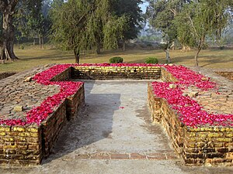

**Present day picture of Mulagandhakuti. The remains of the**[**Buddha**](https://en.wikipedia.org/wiki/Gautama_Buddha)**'s Kuti in Jetavana Monastery. [15]**

## The Buddha’s Journey to Sāvatthī

With deep devotion and a heart overflowing with joy, Anāthapiṇḍika extended his heartfelt invitation to the Blessed One and the Sangha to visit the newly completed Jetavana Monastery. The *Vinaya Piṭaka* recounts*”[16]*  how the Buddha, filled with kindness, graciously accepted the invitation and set forth for Sāvatthī, accompanied by a large assembly of monks.

The sacred journey of the Buddha was not merely a physical movement from one place to another—it was a journey of wisdom, compassion, and transformation. As he wandered from town to town, many came to see him, to listen, and to seek the path to liberation. Finally, he arrived at Sāvatthī and took residence in the serene Jeta Grove, now known as *Anāthapiṇḍika’s Park*.

The *Vinaya Piṭaka* describes the moment when Anāthapiṇḍika, radiant with devotion, approached the Buddha:[17]

*"Anāthapiṇḍika then went to the Buddha, bowed, sat down, and said, ‘Sir, please accept tomorrow’s meal from me together with the Sangha of monks.’”*

The next day, with his own hands, Anāthapiṇḍika reverently offered food to the Buddha and the assembled monks. It was not just an offering of nourishment but a profound act of faith and generosity, symbolizing his dedication to the Buddha and the Dhamma. After the meal, with great humility, he requested the Blessed One to accept the Jetavana monastery as a gift.

The Buddha, in his wisdom, responded with a directive that would ensure the monastery’s lasting benefit:

**“You should dedicate the Jeta Grove to the Sangha as a whole, both present and future.”[18]**

Thus, the monastery was not given to a single individual but to the entire community of Sangha—those who were present and those yet to come—so that the Dhamma could continue to flourish for generations.

### The Buddha’s Words of Appreciation

Having received the Jetavana Monastery, the Buddha expressed his deep appreciation through these profound verses:

"Giving dwellings to the Sangha  
Is praised as the highest offering by the Buddha.  
Therefore, the wise,  
Seeing what is truly beneficial,  
Should build delightful dwellings  
And invite the learned to stay there.

Food, drink, robes, and shelter—  
With an inspired heart,  
He should offer these to the upright ones.  
In return, they will share the Teaching,  
Which leads to the end of suffering.  
And understanding this Teaching in this very life,  
He attains extinguishment, free from all defilements.”[19]

These verses reveal a timeless truth: generosity towards the Sangha is not merely an act of giving—it is a gateway to wisdom and liberation. In supporting those who walk the path of Dhamma, one cultivates merit that leads not only to worldly happiness but to the ultimate freedom from suffering.

Thus, the offering of Jetavana was far more than the donation of land and buildings. It became a sacred refuge—a place where countless beings would hear the Buddha’s teachings, contemplate the Dhamma, and take steps toward the highest peace, *Nibbāna*.

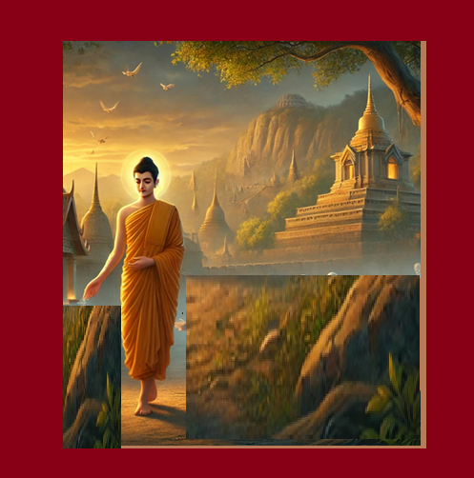

**The Blessed One walking in the Jetavana Monastery [20]**

## The Grand Ceremony of Offering Jetavana Monastery

Another source provides additional details about the grand event of offering and dedicating Jetavana Monastery: *[21]*

*"Anāthapiṇḍika, having made all the necessary preparations for a magnificent ceremony to formally offer and dedicate the monastery to the Buddha, arranged for the symbolic pouring of water as a gesture of devotion. He then made meticulous arrangements to escort the Blessed One to the monastery, as follows:"*

To honour the occasion, Anāthapiṇḍika invited King Pasenadi of Kosala, accompanied by his daughter, Princess Sumana, and her five hundred attendants. Each carried a pot filled with water, along with fragrant flowers and scented offerings.

Following them, his own son led a procession of five hundred companions, all joining in the act of reverence. Next came Anāthapiṇḍika’s brothers, daughters, and their friends and attendants, each offering their heartfelt devotion. Then, in full ceremonial attire, his wife, Punna Lakkhana, proceeded with grace and dignity.

Finally, at the end of the grand procession, Anāthapiṇḍika himself arrived, accompanied by five hundred wealthy merchants from Sāvatthī, each eager to partake in this meritorious deed.

It is said that the donation ceremony of Jetavana extended over nine months, a period filled with great reverence and spiritual transformation. Throughout this time, the Blessed One delivered profound teachings, and a vast number of people attained *sotāpatti*—the first stage of awakening, securing their path toward liberation.[22]

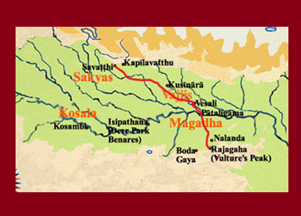

**Map showing the route from Rājagaha to Sāvasti [23]**

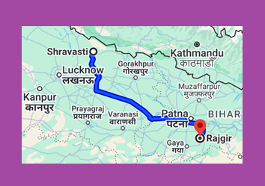



**Modern day map**: **distance from Shravasti to Rajgir: 597.7 km. [24]**

# Significant Dhamma Discourses at Jetavana Monastery

During the Blessed One’s residence at Jetavana Monastery, he delivered many profound teachings that guided disciples toward wisdom and liberation. Among these, two notable discourses stand out—one to Venerable Nanda, illuminating the path beyond worldly attachments, and another to Princess Sumanā, revealing the boundless rewards of generosity.

## Guidance to Venerable Nanda

According to the scriptures, Venerable Nanda[25]—though ordained as a monk—struggled with dissatisfaction in his holy life. Seeing his inner turmoil, the Blessed One, out of boundless compassion, skillfully guided him toward final knowledge (*arahatta*), freeing him from the clutches of delusion and desire. [26]

Upon Venerable Nanda’s awakening, the Buddha uttered this inspired verse (*Udāna*):

*"He who has risen from the quagmire,*  
*Who has severed the thorn of sensual craving,*  
*Who has reached the end of delusion—*  
*That monk is unshaken by pleasure and pain."[27]*

These words encapsulate the triumph of true renunciation—the complete transcendence of worldly suffering. The quagmire of life’s entanglements, which traps so many, can be left behind only through wisdom and unwavering effort.

Another source also confirms that during his stay in Jetavana, the Buddha personally guided Venerable Nanda to attain final liberation. His story stands as a testament to the power of the Dhamma in transforming even the most restless mind into one of deep peace and clarity. [28]

### A Teaching on Generosity to Princess Sumanā

One day, Princess Sumanā, the daughter of King Pasenadi of Kosala, approached the Blessed One with an insightful question regarding generosity. Wishing to understand its deeper implications, she respectfully asked: [29]

*"Bhante, suppose there are two disciples of the Blessed One, equal in faith, virtue, and wisdom—yet one is generous while the other is not. When they pass away and are reborn in a fortunate realm, either as devas or as humans, would there be any distinction between them?"*

The Buddha, ever the compassionate teacher, responded:

"The generous one, having become a deva, surpasses the other in five ways: in celestial lifespan, celestial beauty, celestial happiness, celestial glory, and celestial authority. Likewise, when they are reborn as human beings, the generous one excels in five ways: in human lifespan, human beauty, human happiness, human fame, and human influence."

At the conclusion of this discourse, the Blessed One affirmed the significance of generosity with these words:

*"So it is, Sumanā! So it is, Sumanā! Truly, one has good reason to give alms and perform meritorious deeds, for such acts bear fruit—whether one is reborn among devas, among humans, or embarks upon the spiritual path."*

This teaching reveals the far-reaching impact of generosity—not only in bringing immediate joy but also in shaping one’s future existence. Giving is never wasted; it enriches the giver in this life and beyond, leading ultimately to the highest happiness—the complete liberation of the mind.

# The War Between the Sakyans and Koliyans: The Buddha’s Intervention for Peace

According to tradition and the commentaries, a great conflict once arose between the Sakyans and the Koliyans over the use of water from the Rohini River. **[30]**  Both clans, proud of their heritage and strength, were prepared to wage war against each other. Although this incident is not explicitly mentioned in the canonical scriptures, it beautifully illustrates the Buddha’s supreme commitment to peace and harmony. For this reason, we find it fitting to include it here. [31]

### The Buddha’s Vision of an Impending War

While residing in Jetavana Monastery in Sāvatthī, the Buddha surveyed the world at dawn and saw that a battle was imminent. By evening, blood would be spilled between his own kinsmen—the Sakyans, his paternal relatives, and the Koliyans, his maternal relatives. Moved by great compassion, he resolved to intervene and prevent the destruction of both sides.

Without delay, the Buddha travelled to the banks of the Rohini River, where the two armies stood poised for battle. As tensions mounted, he performed an extraordinary feat—he ascended into the sky and seated himself in mid-air, directly between the warring factions.

### A Moment of Reflection: The Power of the Buddha’s Presence

The sight of the Blessed One hovering above them was enough to stir the conscience of both clans. The Sakyans, upon seeing him, thought:

*"It would be unthinkable to raise our weapons against others in the presence of the Buddha. Let the Koliyans defeat us or take us captive if they wish, but we shall not fight."*

The Koliyans, witnessing this change of heart, arrived at the same conclusion. By mutual consent, they dropped their weapons and bowed in homage to the Buddha. Peace replaced hostility in an instant. The Buddha then descended and seated himself on the sandy riverbank, now transformed into a place of reverence and unity.

### The Buddha’s Words of Wisdom

Seizing this moment of clarity, the Buddha asked:

*"What is the worth of the water of the Rohini River?"*

The assembled clans responded:

*"Exalted Buddha, its value is insignificant."*

The Buddha then asked:

*"And what of the earth—what is its value?"*

*"Its value is limitless,"* they replied.

Then the Buddha posed a final question:

*"How would you measure the worth of the noble royal Khattiya race?"*

*"Its value is beyond measure,"* came the unanimous response.

The Buddha then spoke words that would forever be remembered:

*"For a mere stream of water, which holds little value, would you destroy the priceless noble race of Khattiya? There is no true gain in conflict—only loss, suffering, and ruin."*

To deepen their understanding, the Blessed One recounted past Jātaka tales, illustrating the grave dangers of enmity and the karmic consequences of hatred. As his words sank into their hearts, both sides abandoned their hostility and embraced reconciliation.

### A Legacy of Peace: The Offering of Five Hundred Princes

Out of gratitude for the Buddha’s wisdom and boundless compassion, both the Sakyans and the Koliyans offered two hundred and fifty princes from each clan to become disciples of the Blessed One. These five hundred young men renounced the world, choosing the noble path of the Dhamma over the fleeting path of conflict.

### The Transformation of the Five Hundred Monks

According to the commentaries, [32] after entering the monastic life, these young monks initially struggled with homesickness and longing for their former lives. Understanding their plight, the Buddha took them to the serene Kuṇāla Lake [33] and taught them the *Kuṇāla Jātaka*, a discourse revealing the fleeting and deceptive nature of worldly attachments.

As they listened with deep reflection, the five hundred monks attained *sotāpatti* (stream-entry), securing their path toward liberation. Not long after, through diligent practice under the guidance of the Blessed One, they realized the highest goal—*arahatta* (full awakening), completely freeing their minds from all defilements.

Thus, what began as a conflict fuelled by pride and greed was transformed into an opportunity for spiritual awakening, all through the wisdom and compassion of the Buddha

After renouncing the household life, the five hundred princes who had become monks under the guidance of the Buddha remained steadfast in their new path. When their wives sent messages, pleading for their return, the monks responded with unwavering resolve:

*"We have now entered a life beyond worldly ties. The household life is no longer our home."*

Undeterred, the women sought the help of Mahāpajāpatī Gotamī, the Buddha’s stepmother and a revered figure among them. They approached her with deep longing and respect, urging her to request the Buddha to grant them the opportunity to go forth into the monastic life.

Moved by their sincerity, Mahāpajāpatī gathered the women under her care and approached the Blessed One with a heartfelt plea. This event, described in the texts, marked a pivotal moment in history—the beginning of the Bhikkhunī Sangha, the Order of Nuns, which would offer women the same path to liberation as their male counterparts. In section:15-1 describes the going forth of Mahāpajāpatī and the five hundred women.

The Buddha’s First Visit to Vesālī – The Sixth Walking Tour

During this period, another remarkable event unfolded. The great city of Vesālī was suffering from three devastating calamities—famine, disease, and disturbances from non-human beings. [34] Seeking refuge, the noble Licchavi princes of Vesālī sent an earnest invitation to the Buddha, imploring him to come and restore peace and harmony to their land.

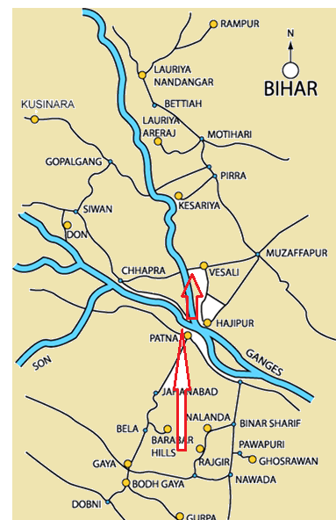

**Map showing the locations of Rājagaha and Vesāli [35]**

The Blessed One, with boundless compassion, accepted their invitation. This sacred journey, which we refer to as the *Sixth Walking Tour*, was an extraordinary testament to the Buddha’s tireless dedication to the welfare of all beings. Setting out from Rājagaha with sangaha, he walked to Pātaligāma (*modern-day Patna*), a distance of approximately 103 kilometres. There, King Bimbisāra, a devoted supporter of the Dhamma, arranged for the Buddha and the Sangha to cross the sacred waters of the Ganges on his royal barge. Having reached the northern bank, the Blessed One and the sangha continued their journey on foot, accompanied by the Licchavi princes, traveling another 35 kilometres to reach the city of Vesālī. The arrival of the Blessed One in Vesālī. marked the beginning of a profound transformation, as the power of his presence and teachings would soon dispel the suffering of the people and restore harmony to the land. (see: maps below).

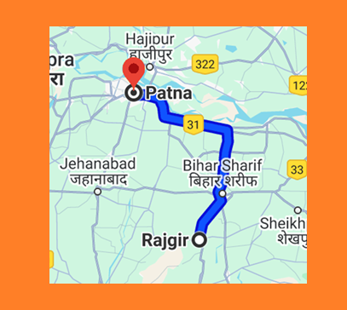

**Modern map showing the distance from Rajgir (Rājagaha) to Patna (Pātaligāma) 103 km [36]**

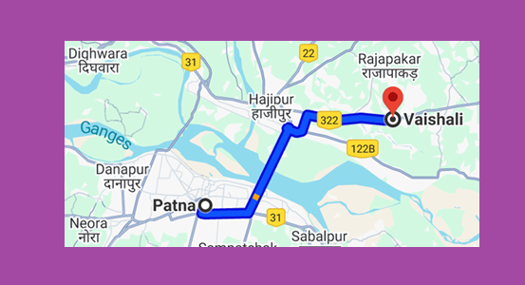

**Modern map showing the distance from Patna (Pātaligāma) crossing the river to Vesali 35 km [37]**

Tradition recounts that King Bimbisāra made arrangements for the Buddha and the Saṅgha to cross the Ganges River and enter Vesālī, the capital of the Licchavis. At that time, the city was afflicted by a devastating epidemic, and as the Buddha and the Saṅgha arrived, the Devas caused a heavy downpour to cleanse the city of the many dead bodies.

Once the city was purified, the Blessed One entrusted the recitation of the *Ratana Sutta*—the discourse on the Three Jewels[38] —to Venerable Ānanda. Following the Buddha’s instructions, Venerable Ānanda, accompanied by monks and the citizens of Vesālī, circumambulated the city while sprinkling water blessed by the Buddha. As a result, all malevolent spirits were dispelled, and the entire city was safeguarded by the powerful invocation of the highest virtues of the Triple Gem—Buddha, Dhamma, and Saṅgha.

**Whatever beings have gathered here,**  
**whether of the earth or in the firmament,**  
**may the minds of all be filled with joy,**  
**and may they listen attentively to these words.**

**Therefore, all beings, be heedful and kind,**  
**be friendly to this generation of men.**  
**They who bring offerings by day and by night,**  
**as they are devoted, so should you protect them.**

At that moment, a great assembly of Devas manifested in the sky, offering homage to the Blessed One. Among them, Sakka, the lord of the Devas, is said to have recited the final three stanzas of the *Ratana Sutta*:

Thus, through the supreme power of the Buddha’s discourse and the devotion of the people, Vesālī was liberated from its suffering, and harmony was restored.

### Leaving Vesālī and Arriving at Rājagaha

The Blessed One remained in the city of Vesālī for two weeks before setting out on his return journey to Rājagaha. The Licchavi princes, filled with reverence and devotion, accompanied the Buddha as he travelled to the northern bank of the River Ganges. The journey to the riverbank took three days. [39]

On the other side of the river, King Bimbisāra, the devoted patron of the Buddha, awaited his arrival with a royal barge. With great honour, the king personally ferried the Blessed One across the Ganges and led him and the Saṅgha back to Rājagaha. The entire journey spanned five days.

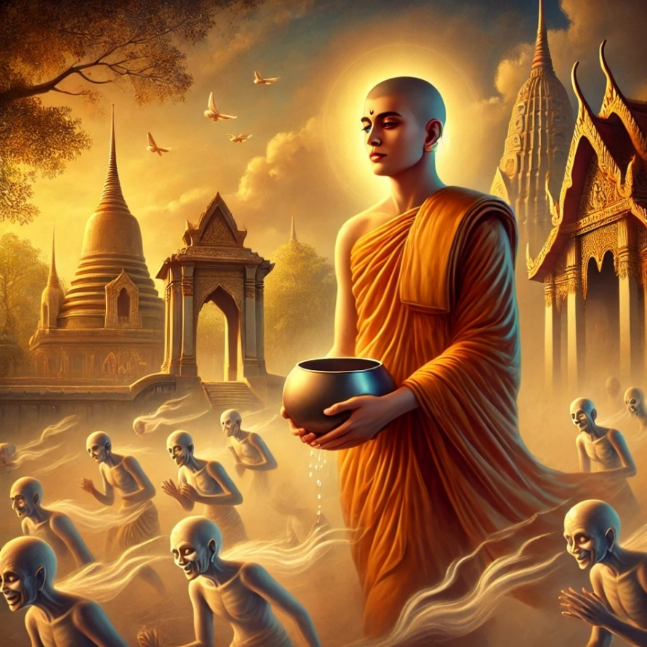

**Venerable Ãnanda spinking blessed water from the bowl of the Buddha at Vesali [40]**

## The Ordination of Venerable Uggasena

The story of Venerable Uggasena is a well-known account from the time when the Buddha was residing in Rājagaha. [41] It carries a profound Dhamma teaching, illustrating the transient nature of worldly pleasures and the power of wisdom in overcoming attachment.

During a festival season, a traveling troupe of acrobats arrived in Rājagaha to entertain the king and the townspeople. Among the performers was the troupe leader’s daughter, a woman of extraordinary beauty and grace. A young man named Uggasena, the son of a wealthy family, was captivated by her charm and enchanting dance. Overcome by desire, he resolved to make her his wife and implored his parents to arrange the marriage.

As expected, his parents disapproved of his request. But Uggasena, consumed by passion, refused to eat, threatening to waste away in despair. Fearing for their son’s life, his parents reluctantly sent a messenger to the girl’s father, offering a substantial sum of money in exchange for her hand. However, the proud acrobat rejected the proposal, declaring that if the young man wished to marry his daughter, he must first prove himself by joining the troupe and mastering their craft.

Blinded by desire, Uggasena abandoned his privileged life, forsaking his loving parents, wealth, and social status, to follow the acrobats. Having no prior training, he was assigned menial tasks, serving as a caretaker and assistant. Eventually, moved by Uggasena’s unwavering devotion, the troupe leader consented to the marriage.

However, married life did not unfold as Uggasena had imagined. His wife frequently belittled him for his lowly status within the troupe, wounding him with harsh words. Determined to earn her respect, Uggasena pleaded with his father-in-law to train him as an acrobat. Over time, he became a master performer, capable of astounding feats, including balancing atop a towering bamboo pole.



**Uggasena’s acrobatic display in Rājagaha [42]**

One day, eager to reclaim his dignity, Uggasena returned to Rājagaha to showcase his skills. As he prepared for his performance, the Blessed One, with his boundless compassion, surveyed the world and perceived that Uggasena had the potential to transcend saṃsāra. Thus, the Buddha, accompanied by the Saṅgha, made his way to the performance site.

The moment the Buddha appeared, the crowd’s attention shifted toward him, leaving Uggasena’s spectacle unnoticed. Witnessing this, Uggasena became disenchanted with his own abilities, realizing the emptiness of worldly pursuits. Sensing his moment of insight, the Blessed One spoke these profound words:

**"Let go of the past, let go of the future, let go of the present. Having gone beyond rebirth, with your heart freed in every respect, you will no longer return to birth and old age."** [43]

*Muñca pure muñca pacchato- Majjhe muñca bhavassa pāragu  
Sabbattavimuttamānaso- Na punaṃ jātijaraṃ upehisi.*

At that very moment, standing atop the bamboo pole, Uggasena attained full enlightenment, realizing the noble state of Arahantship. Descending from the pole, he approached the Buddha with deep reverence and paid homage. Seeing his spiritual readiness, the Buddha simply uttered, **"Come, Bhikkhu."** With that, Uggasena was instantly ordained, becoming a noble disciple of the Blessed One.

### Concluding Reflections

The inspiring journey of Bhikkhu Uggasena reminds us of the fleeting nature of worldly attachments and the limitless potential for liberation through wisdom. No matter how deeply one is entangled in desire, the Dhamma provides a path to freedom.

In the next section (15-1), we will explore the Buddha’s return to the city of Vesālī, where he spent his fifth rainy season retreat. During this time, many extraordinary events unfolded, further illuminating the profound impact of the Buddha’s presence.

### End Notes: Section 14-3

1. Chapter 20: The Great Chronicles of Buddhas by Venerable Mingun Sayadaw. * Ambalaṭṭhikā: a royal park on the road between [Rājagaha](https://www.aimwell.org/DPPN/rajagaha.html) and [Nāḷandā](https://www.aimwell.org/DPPN/nalanda.html). It contained a royal rest-house *(rājāgāraka)* in which the Buddha and members of the Order used to stay in the course of their journeying: Source: Dictionary of Pāli Proper Names by G.P. Malalasekera.
2. MN:61 (Ambalaṭṭhikārāhulovāda Sutta) * this discourse was taught to Rāhula when he was seven years old, thus very shortly after his ordination, see: MN: Note:637.
3. MN:61
4. Ibid.
5. VP:Chulavagga:Kd16.
6. He was the brother-in-law of Anathapindika.
7. VP: Chulavagga:Kd16.
8. VP: Chulavagga: Kd16: 2.1
9. He was a wealthy merchant from Savassti, the Buddha declared him as the foremost among donors, see: AN1:249. * The story of Anāthapiṇḍikas first meeting with the Buddha also described in SN10: 8.* His given name was Sudatta, “Anāthapiṇḍika” being a nickname meaning “(giver) of alms to the helpless”, he was so called because of his generosity, see: SN: Note:584. For more details

   see Bhikkhu Ñāṇamoli’s , *Life of the Buddha.*
10. VP: Chulavagga: Kd16: 2.1 * this verse also mentioned in SN10.8 & AN3:35.
11. Ibid.
12. Ibid.
13. Ibid.
14. Chapter 20: The Great Chronicles of Buddhas by Venerable Mingun Sayadaw.
15. Source: https://en.wikipedia.org/wiki/Jetavana
16. VP: Chulavagga: Kd16:2.7.
17. Ibid.
18. Ibid.
19. Ibid.
20. AI generated image.
21. Chapter 20: The Great Chronicles of Buddhas by Venerable Mingun Sayadaw.
22. Ibid.
23. Source: Buddhist India by T.W. Rhys Davids
24. Google map
25. Section 2 describes his going forth.
26. Ud:3.2.
27. Ibid.
28. Chapter 20: The Great Chronicles of Buddhas by Venerable Mingun Sayadaw * Venerable Nanda becoming an arahant was described in Section: 2.
29. AN5:31 (Sumana sutta).
30. Sakyans were from Kapilavatthu; Koliyans were one of the republican clans in the time of the Buddha. The Koliyā owned two chief settlements — one at [Rāmagāma](https://www.aimwell.org/DPPN/ramagama.html) and the other at [Devadaha](https://www.aimwell.org/DPPN/devadaha.html). Both of these clans related to the Buddha. Source: Dictionary of Pāli Proper Names by G.P. Malalasekera.
31. Part 6 - War between the Sakyans of Kapilavatthu and of Koliya: The Great Chronicles of Buddhas by Venerable Mingun Sayadaw
32. See: AN: Note: 1729.
33. Kuṇāla, one of the seven great lakes in the region of the [Himavā](https://www.aimwell.org/DPPN/himava.html). The Buddha once visited it with a large concourse of Sakyan youths who had joined the Order, and on that occasion, he taught the [Kuṇāla Jātaka](https://www.aimwell.org/DPPN/kunala_jataka_536.html). Source: Dictionary of Pāli Proper Names by G.P. Malalasekera.
34. During that time the City Vesali was affected by a three great disaster: famine, havoc caused by evil spirits and epidemic which cause large number of deaths, for details: see: Chapter 22: The Great Chronicles of Buddhas by Venerable Mingun Sayadaw.
35. Source: BUddhaNet: https://www.buddhanet.net/e-learning/pilgrim/p_map2/
36. Google map.
37. Ibid.
38. KP:6 (Ratana sutta).
39. Chapter 22: The Great Chronicles of Buddhas by Venerable Mingun Sayadaw.
40. AI generated image.
41. His story is described in detail in Chapter 22: The Great Chronicles of Buddhas by Venerable Mingun Sayadaw. * His story also given in Dhammapada atthakatha, see: 24.6 The Story aboutUggasena-Uggasenavatthu: A Revised Translation of the Dhammapada Aṭṭhakathā together with a  
    New Translation of All the Verse TextsE W Burlingame, Ānandajoti Bhikkhu
42. Source: https://www.buddha-brothers.com/chapters/2406.html
43. Dhp:348 (Craving- translated by Bhikkhu Sujato).